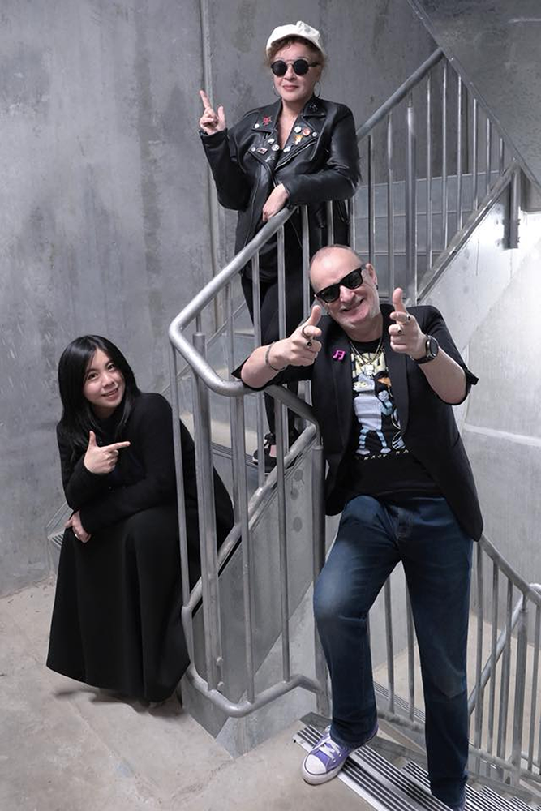
Formed by vocalist Monika Ciura and Synth player Tony Irvine way back in 2006, for 15 years Disco Computer had shit tons of fun performing live in Multiple states and regional areas. Monika even finally took up playing Synthesizers alongside Tony as well as continuing her lead vocal duties in 2016 and the results paid off spectacularly!
Fast forward to 2020, not too long after our first ever Facebook live performance in July of that year, it was discovered that Monika had developed a particularly nasty strain of brain tumours, beginning her battle with cancer. Sadly, Monika lost her battle with cancer on July 4th, 2021.

After multiple discussions with her brother David, it was decided to keep Disco Computer going,
partly for Tony’s sanity, but also in honour of Monika’s memory.

In late 2022 after placing numerous ads for a singer, Disco computer is joined by Nesina Viola. The sound has changed to reflect that, with Nesina’s background in blues music and a vocal range a whole octave lower than Monika’s, Disco computer’s sound was always going to change.
And then, just to shake things up even further, in late 2023 Disco computer became a trio! Chinese born Melburnian Lu Nie brings her not inconsiderable piano, Synthesizer and vocal skills to the fore. And just mere days after joining, Lu's skills were put to the test as Disco Computer performed live on legendary Melbourne radio station 3PBS FM
Disco Computer will get your party pumping with its infectious collection of originals and covers in classic late 80s/Early 90s styles! Hopefully Disco Computer will soon be at a venue (Both physically and online) near you in the not so distant future.

